ECE 3300L

Lab 5

Instructor: Mohamed Aly

Group A

Sami Elias 012546378 [samielias@cpp.edu](mailto:samielias@cpp.edu)

Joseph Popoviciu 014357772 jdpopoviciu@cpp.edu

Objective:

Previously, we made an up/down counter for single digits. We also made an up counter for multi digits. Now the objective is to make a multi digit up/down counter.

Results:

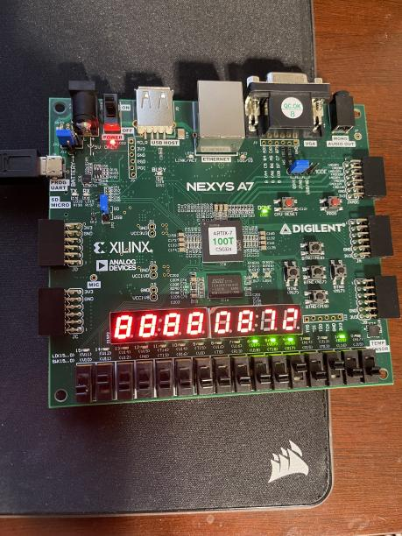

Image 1: counting to 3 digits

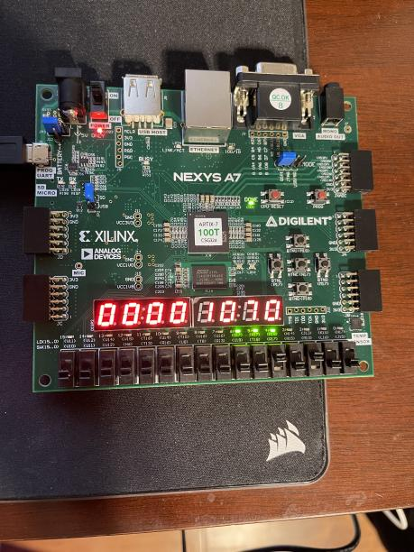

Image 2: counting to four digits

Conclusion:

We were able to create a multi digit up/down counter that can count up or down at different speeds. We used a clock divider to enable us to change the speed of the counting. We also included an enable switch which turns the counter on and off. The clock divider works the same way it did in the previous labs. The most significant bit on the left, and the least significant bit on the right.